**CN LAB WEEK 10**

**PES1UG20CS806**

**DIVYANSHU SHARMA**

# **IPv6 Address and Topology Creation**

* The following topology was created and deployed on ClayNet.
* 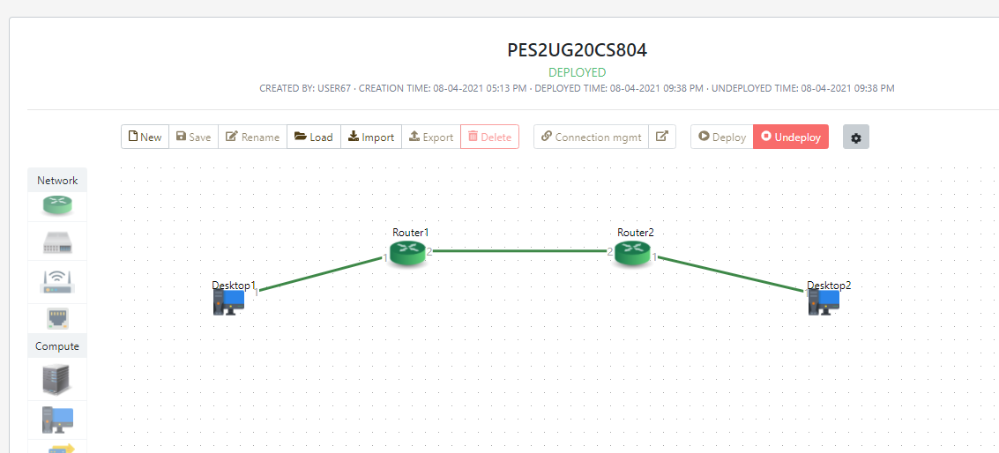The two workstations are labelled as Alice and Bob for this experiment.
* The end-systems are configured initially as follows

|  |  |  |
| --- | --- | --- |
| End System Name | IP Address | Gateway |
| Alice (Desktop1) | 2001::02/64 | 2001::02 |
| Bob (Desktop) | 2003::02/64 | 2003::01 |

# **Router Configuration**

* IPv6 Addresses must be set for each router using the console.
* We first enable the IPv6 mode in both routers.

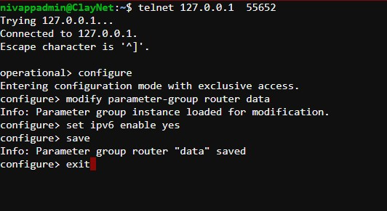

**Router 1**

* Router 1 is configured by assigning the IPv6 Address 2001::01/64 to the if-port-1

interface as shown below.

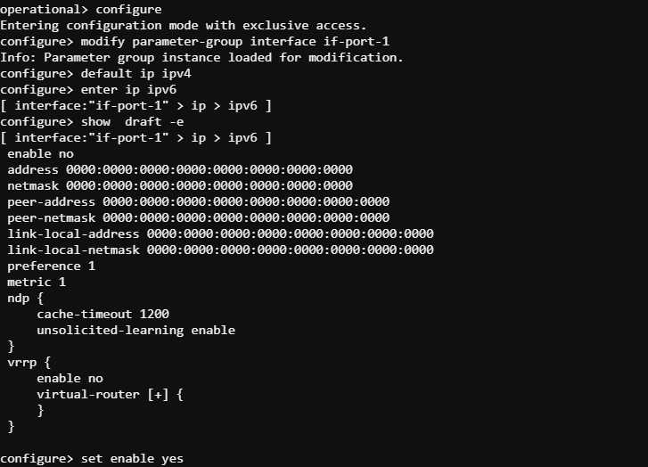

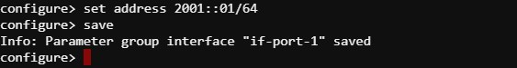

* Similarly, the IPv6 Address of 2002::01/64 is set for the if-port-2 interface as shown below.

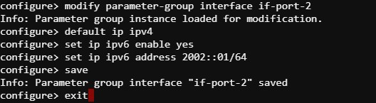

* 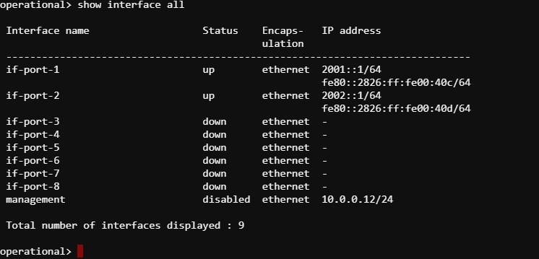The full interface configuration for Router 1 is shown below.
* The routing table entries are now configured. After configuration, the routing table for Router1 can be seen below.

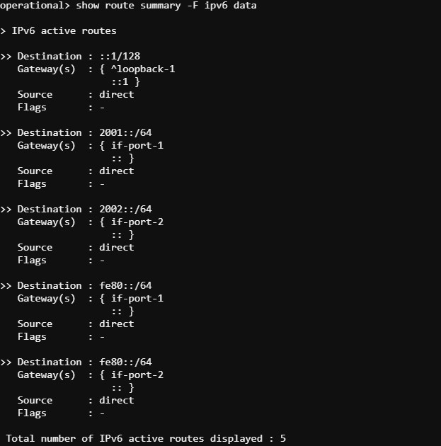

## Router 2

* 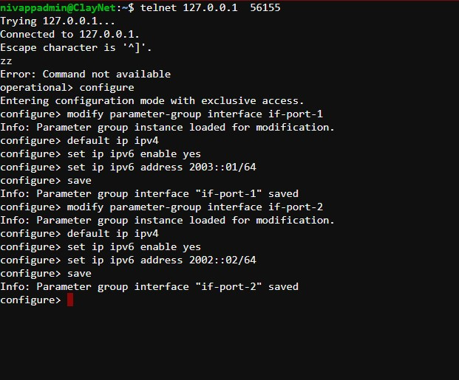The IPv6 Addresses for the interfaces if-port-1 and if-port-2 are set similarly.

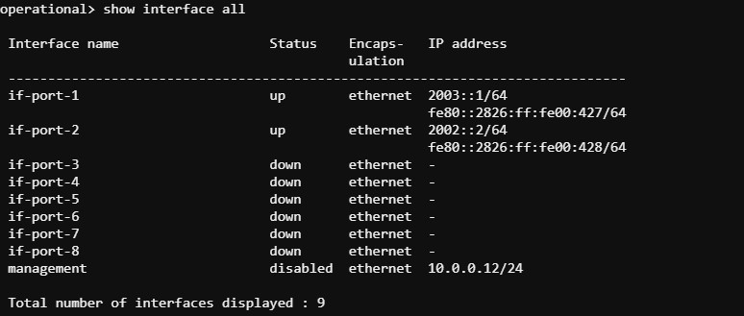

* The routing table entries are configured as well and are shown below.

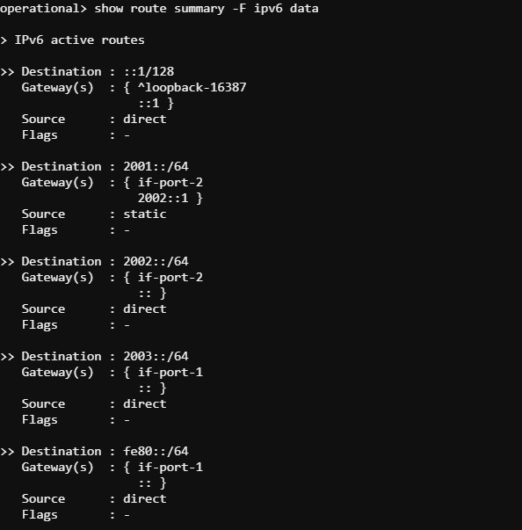

# **Observations**

3.1 Ping Command

* Successful ping requests can be sent from Alice to Bob workstations as shown below.
* Since there are 2 hops between the workstations, the TTL value is reduced by 2 from its default value of 64 to 62.

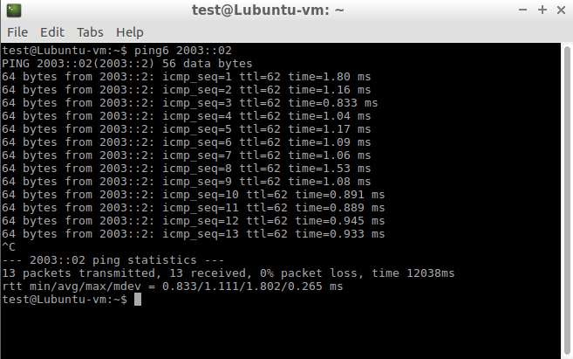

3.2 Tracepath Command

* A similar tracepath command can be issues from Alice to Bob as shown below.

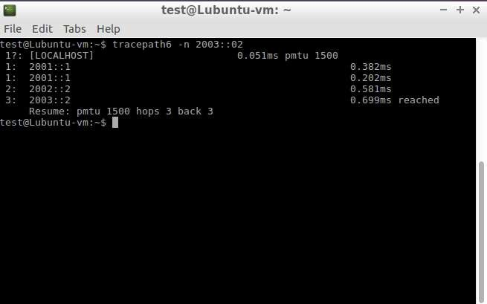

3.3 Neighbour Table

We can view the neighbour table for Router1 using the following command.

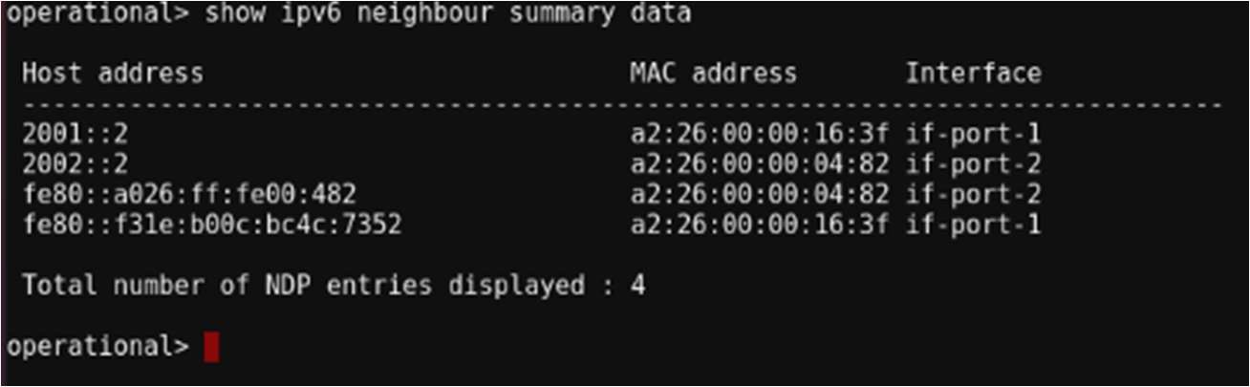

We can also obtain the link-local address of interface if-port-2 on Router2 using the following command

